EnSaLine S Side Mounted agitator
With the Alfa Laval EnSaLine™ S Side Mounted agitator, you save time and operating costs from day one. Delivering massive energy savings, easy maintenance and prepared for industrial connectivity, EnSaLine agitators raise the bar for agitator performance. The impeller design ensures gentle product treatment, high yield, excellent cleanability and cuts energy consumption by up to 80%. Maintenance can be carried out by one technician in less than 30 minutes from the outside of the tank.
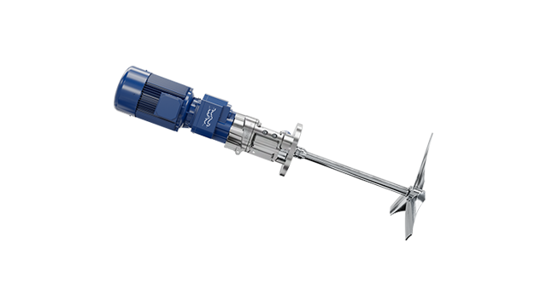
Excellent performance. Effortless operation and maintenance
- Save time on maintenance. All seals and bearings are contained in one, replaceable cartridge for easy and safe maintenance in less than 30 minutes.
- Avoid contamination. The fully flushable design and the seal housing offer excellent cleanability and increase product safety.
- Improve energy efficiency. EnSaFoil impellers deliver higher efficiency than comparable technologies, with energy consumption by up to 80%.
- Avoid unplanned downtime. Sensors monitor operating conditions to prevent sudden failures, optimize service intervals and extend equipment lifetime.
- Guaranteed performance. EnSaLine agitators deliver high performance from day 1.
EnSaLine™ is purpose-built for tanks used in food, dairy, beverage pharmaceutical, and home and personal care industries. EnSaLine agitators meet the highest hygiene standards. They are 3A certified, and all non-metallic parts are fully FDA-compliant. Cleaning in place can be performed while the agitator is running. EnSaline agitators are available in diameters from ø250 to 1900 mm.

How do EnSaline side mounted agitators work? 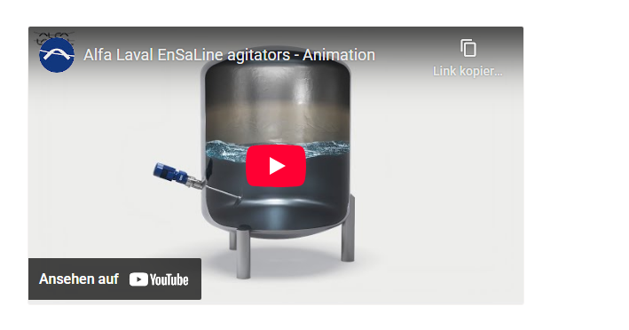
Designed for efficiency
EnSaLine side mounted agitators set a new standard for exceptional mixer and agitator performance. An electrical motor transmits, either directly or via a gearbox, the energy required for mixing and blending to the tank agitator shaft. The shaft rotates, turning the agitator’s unique energy-saving impellers.
Effective mixing and blending
The movement of the EnSaFoil two or three blade impeller creates a high flow rate with low shear due to the highly effective axial pumping effect on the fluid. This results in effective mixing and blending of the entire contents of the tank. The high mixing efficiency cuts energy consumption by up to 80%. The design also minimizes heat transfer to the product, reducing the load on the cooling systems.
Easy maintenance
EnSaLine agitators are designed for effortless maintenance that can be carried out by one technician in only 30 minutes with rapid and tool-free access. The shaft remains securely fixed, eliminating the need to enter the tank. Sealings and O-rings can be replaced from the outside.
Full connectivity
Prepared for wireless condition monitoring, EnSaLine mixers and agitators provide full control during daily operation and enable predictive maintenance.

